**THE TRAGEDY OF FLIGHT – A COMPREHENSIVE CRASH ANALYSIS**

1. **INTRODUCTION**
   1. **OVERVIEW**

**An airplane crash analysis is a detailed investigation into the causes of an aviation accident. The goal of an airplane crash analysis is to identify any factors that contributed to the accident, with the ultimate goal of improving safety and preventing future accidents. The process of conducting an airplane crash analysis typically involves the collection and analysis of a wide range of data, including information about the aircraft and its systems, the operators, and any other relevant factors. This data is typically collected from Kaggle. Once the data has been collected, it is analysed through tableau, to identify any potential causes of the accident. The results of an airplane crash analysis are typically published in a report, which may include recommendations for improving safety and preventing similar accidents in the future. These recommendations may be implemented by the relevant authorities or industry organizations**.

* 1. **PURPOSE**

**The primary purpose of**[**air crash**](https://simpleflying.com/tag/air-crash/)**investigators is to determine the cause of the crash and any contributing factors involved in the crash. Investigative authorities also provide recommendations for safe operations. In the first few hours after a major air crash is reported, a team of investigators is deployed to (or in the whereabouts of) the scene.In the United States, the National Transportation Safety Board (**[**NTSB**](https://simpleflying.com/tag/ntsb)**), a government agency, is responsible for investigating all major aviation accidents. Since it was formed in 1967, the NTSB has completed more than 132,000 accident investigations and also participates in investigations with other accident safety authorities**.

1. **PROBLEM DEFINITION & DESIGN THINKING**
   1. **EMPATHY MAP**

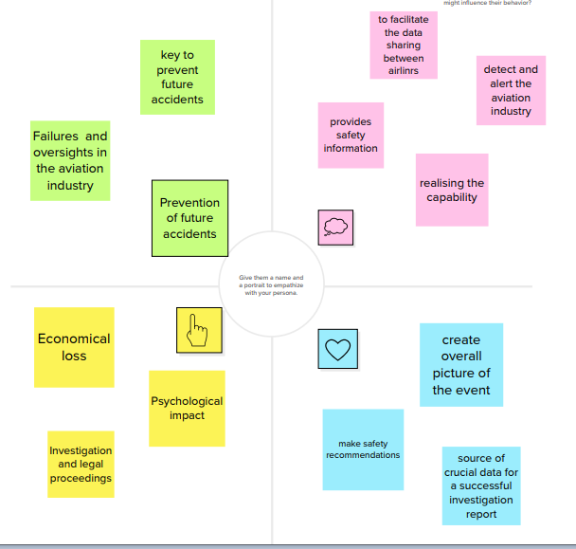

* 1. **IDEATION & BRAIN STORMING MAP**

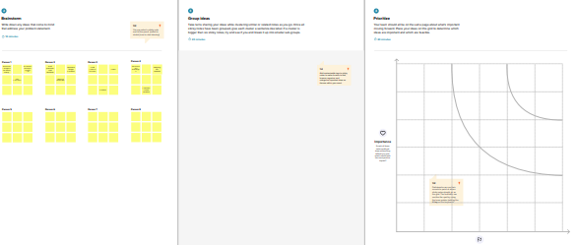

**3**.result

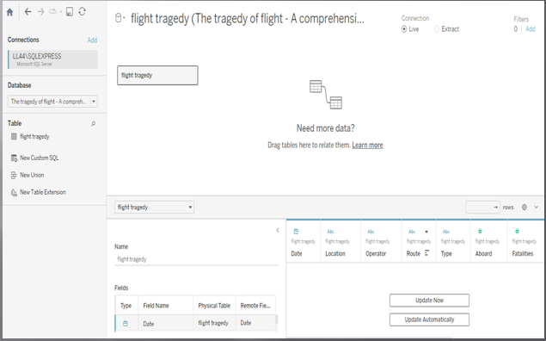

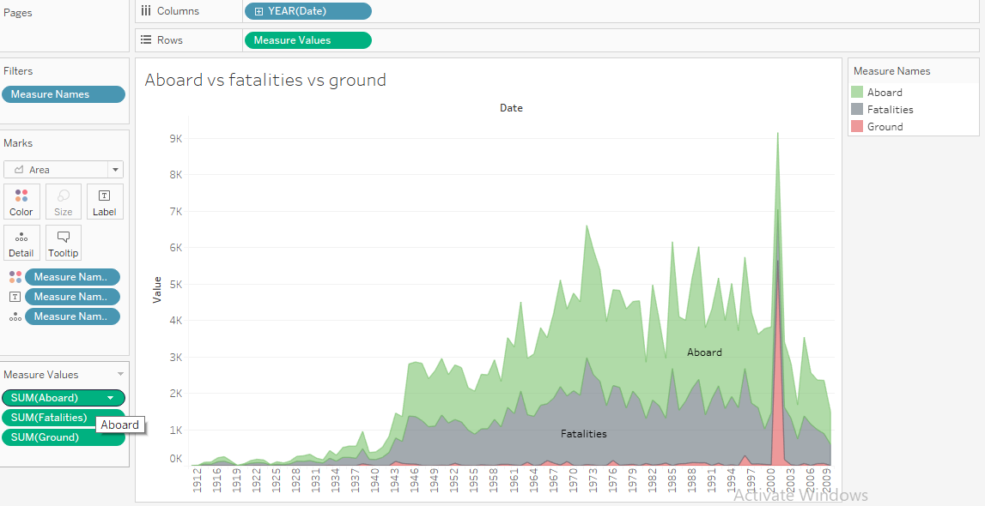

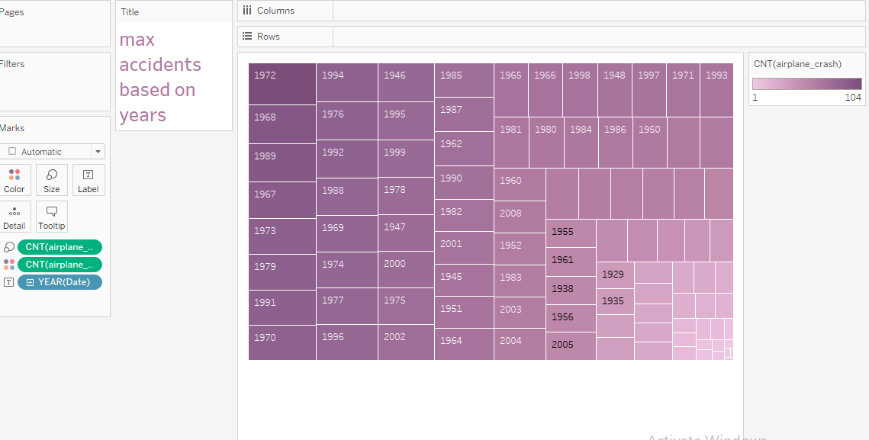

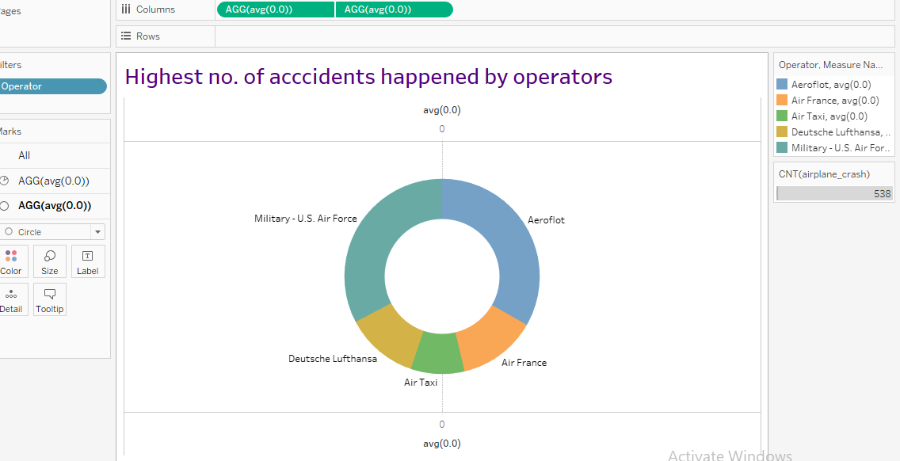

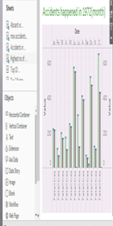

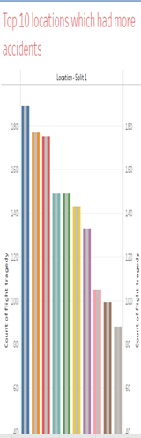

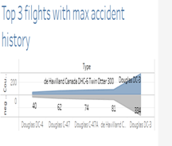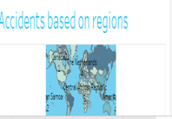

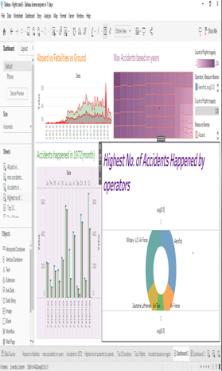

Dashboard 1- <https://public.tableau.com/views/dashboard1_16821447306210/Dashboard1?:language=en-US&publish=yes&:display_count=n&:origin=viz_share_link>

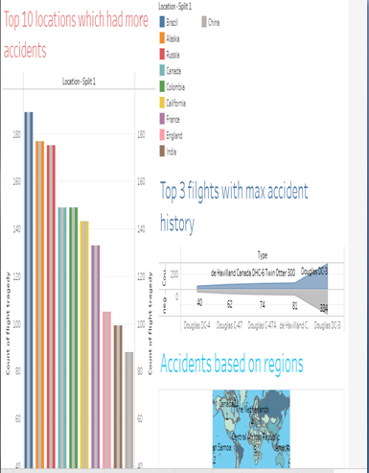

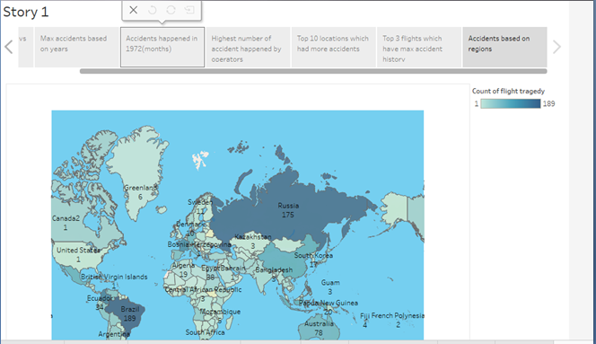

Dashboard 2 - <https://public.tableau.com/views/dashboard2_16821451457370/Dashboard2?:language=en-US&publish=yes&:display_count=n&:origin=viz_share_link>

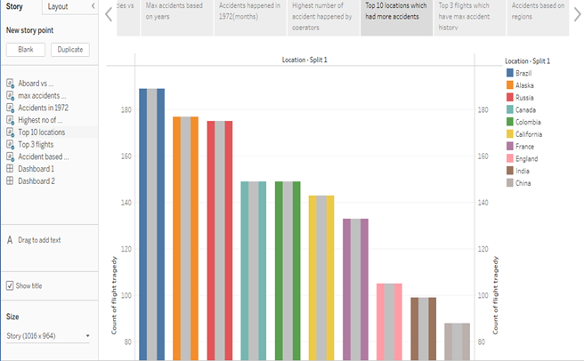

Story - <https://public.tableau.com/shared/DYDZ8BD8G?:display_count=n&:origin=viz_share_link>

1. **ADVANTAGES AND DISADVANTAGES**

**ADVANTAGES**

Aircraft accident indicates certain failures and oversights in the aviation industry. Aircraft accident investigation involves the collection and analysis of various data in order to draw conclusions and make safety recommendations that will prevent aircraft accidents caused by similar causes in the future. Therefore, a properly conducted investigation is a key to prevent future accidents. This paper analyses the importance of flight recorders as a source of crucial data for a successful investigation result. Flight recorders create an overall picture of the event and present an indispensable tool in discovering the cause of an aircraft accident. In addition to standard flight recorders used in aircraft, this paper also provides an overview of new technologies that will certainly contribute to even better analysing methods and prevention of future accidents.

**DIS ADVANTAGES**

Flying under visual flight rules into instrument meteorological conditions, commonly known as VFR into IMC, remains among the top five causes of fatal general aviation accidents and among the top with the highest lethality. These largely preventable accidents impact pilots including those with an instrument rating. Learn from the pilots who survived the encounter and what makes these accidents so deadly. Prevention and escape come down to knowledge, good decision making, real-world training, and honing skills through ongoing proficiency.

1. APPLICATIONS

The most common reasons for plane accidents are pilot error, mechanical failure, human error, etc. These parameters are explained as follows:

Pilot Error – Roughly 50% of the aircraft losses incur due to pilot error. There are many chances for The pilots to cause errors from failing to program correctly to miscalculation of the required fuel

Mechanical Failure -Despite developments in model and manufacturing standards of the aircrafts, mechanical failures account for 20% of aircraft losses.

Weather - Despite of having multiple electronic aids, aircrafts still struggle to function properly when the weather turns out to be unpleasant like in storms, snow and fog.

Sabotage - The dangers posed by sabotage are much less than many people seem to believe. Approximately 10% of aircraft losses occur due to sabotage.

Human Error – Mistakes can be made by humans operating when required to work for longer hours. Air traffic controllers, dispatchers, loaders, etc are some of the jobs that are operated by humans.

1. **FUTURES SCOPES**

**An airplane crash analysis is a detailed investigation into the causes of an aviation accident. The goal of an airplane crash analysis is to identify any factors that contributed to the accident, with the ultimate goal of improving safety and preventing future accidents. The process of conducting an airplane crash analysis typically involves the collection and analysis of a wide range of data, including information about the aircraft and its systems, the operators, and any other relevant factors. This data is typically collected from Kaggle. Once the data has been collected, it is analysed through tableau, to identify any potential causes of the accident. The results of an airplane crash analysis are typically published in a report, which may include recommendations for improving safety and preventing similar accidents in the future. These recommendations may be implemented by the relevant authorities or industry organizations.**

1. **CONCLUSION**

**This analysisrevealed that among the pilotsthat caused the targeted accidents, 22 had flight experience for 301 to 1000 hours and 20 had 1001 or more hours of experience. By age, those in their 50s and 60s combined were 34, accounting for nearly 60% of the total. Pilots with the total flight time of 301 to 1000 hours may have accumulated experience in familiarization flights and recreational flights after obtaining a license and may have become confident in their skills. On the other hand, the analysis of causal factors shows the involvement of human factors, such as wrong assumptions carelessness and negligence, as well as a gap between perceptions and reality concerning skills, in many of the accidents.There was also a case where a pilot's excessive self-confidence triggered the accident. In the interviews,some pointed out the importance of cautioning oneself against all dangerous situations instead of taking them lightly. However experienced you may be, you should refrain from dangerous and recklessflights. Be aware that you may do something careless or make errors at anymoment, be sure to conduct periodic checks and prior confirmation, and try to take action as soon as possible instead of ignoring any abnormalities or anxiety you may notice during the flight. Such attitude of each pilot will lead to preventing aircraft accidents. Lastly, we extend our appreciation to the people from the Japan Flying Association and the AOPA-JAPAN who kindly responded to our interviews and offer our best wishes for their further success**